

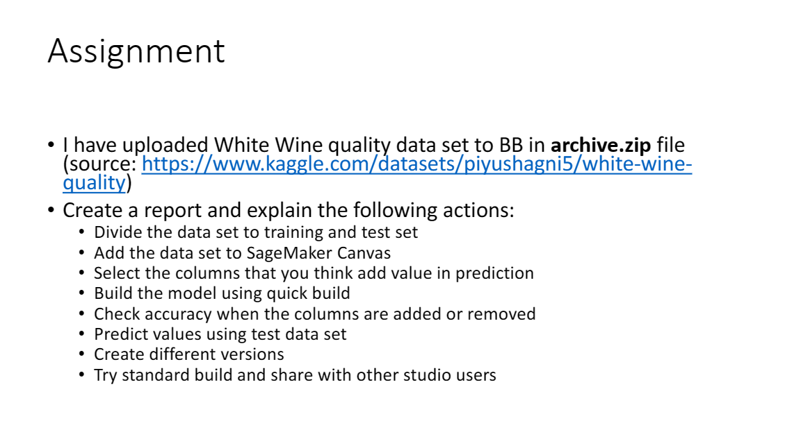

**Main Learning**

**The model’s target value was set to “Quality”. Here, we are classifying the quality of white wines.**

**The quick model required less time compared to standard model, but with standard model the sharing option with different users gets unlocked. This helps the shared user to deploy the shared model with sagemaker studio.**

**The quick model gave accuracy of around 68% where no preprocessing was done. Whereas, standard model gave accuracy of around 67% accuracy. This is because I have deleted the column seeing the correlation value from the statistics of the columns. The least three significant features were removed. After removing three features, the accuracy didn’t fall drastically. With this it was confired that if the correlation value is least, than that particular feature shouldn’t be considered as it doesn’t impact the overall model significantly.**

**Steps followed -**

**Step 1: Created Domain and two users.**  
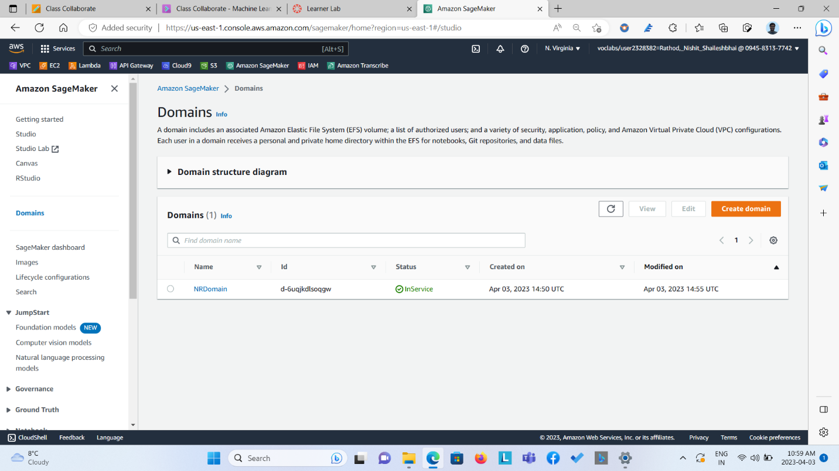  
  
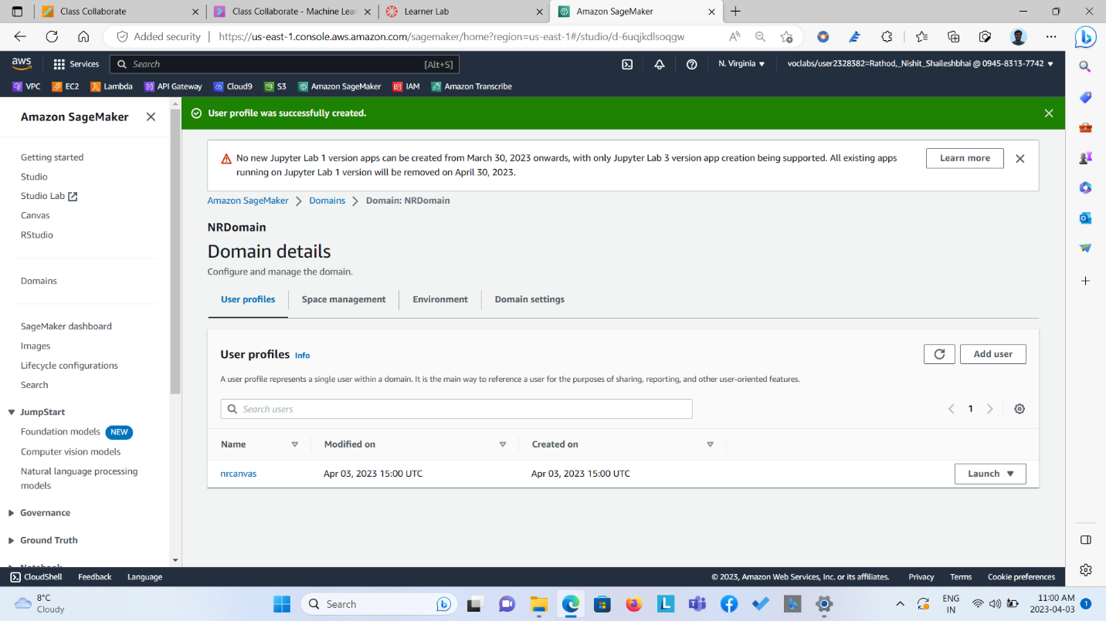

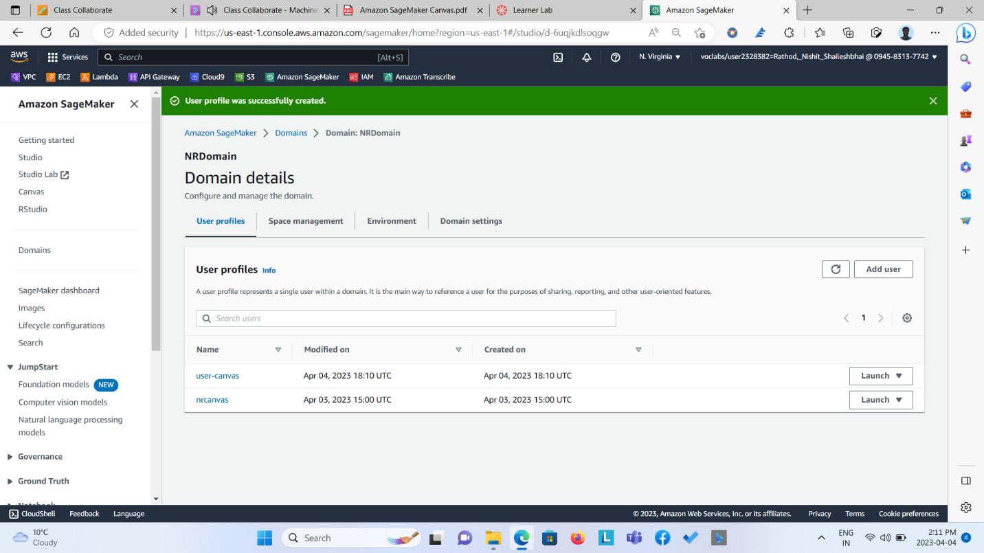

Step 2: Created S3 Bucket and Uploaded Train and Test Dataset.

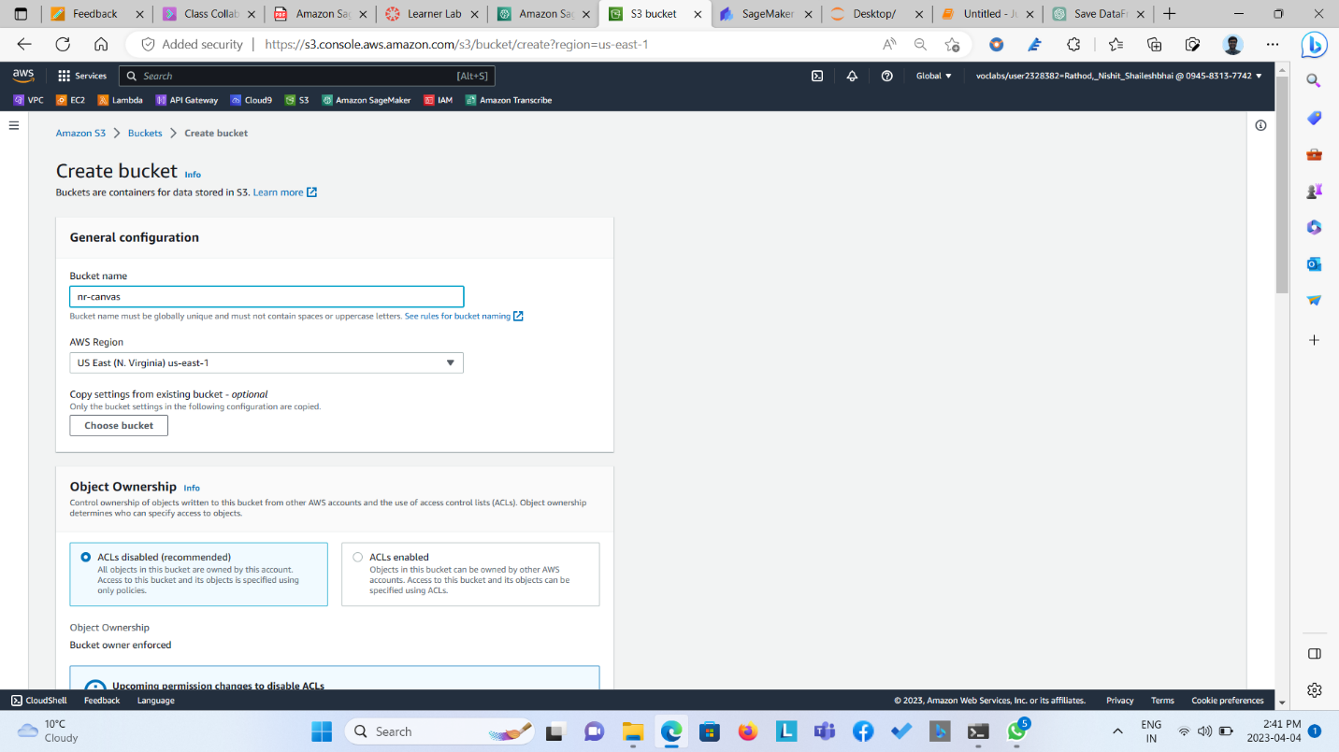  
  
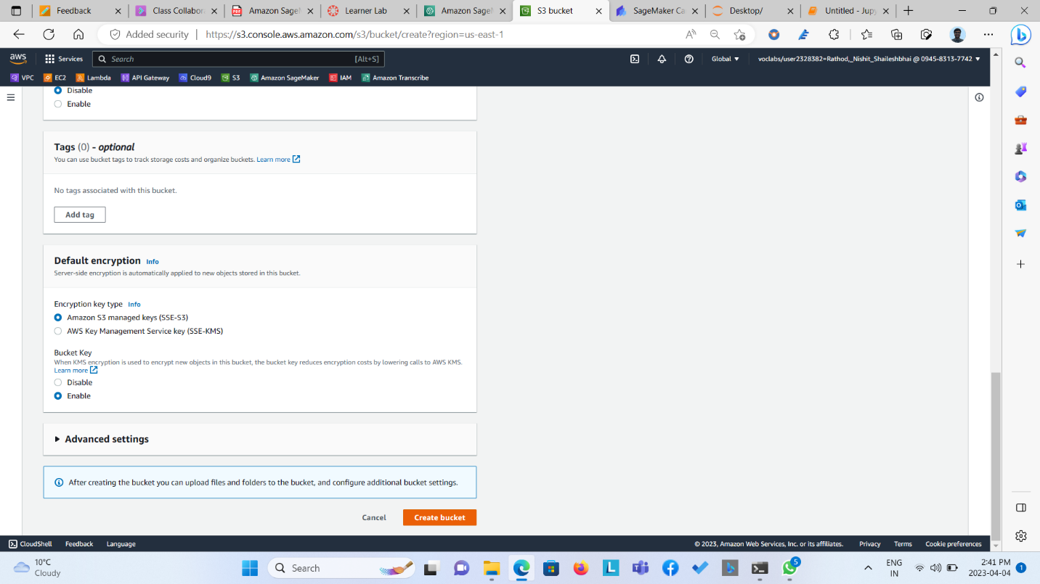  
  
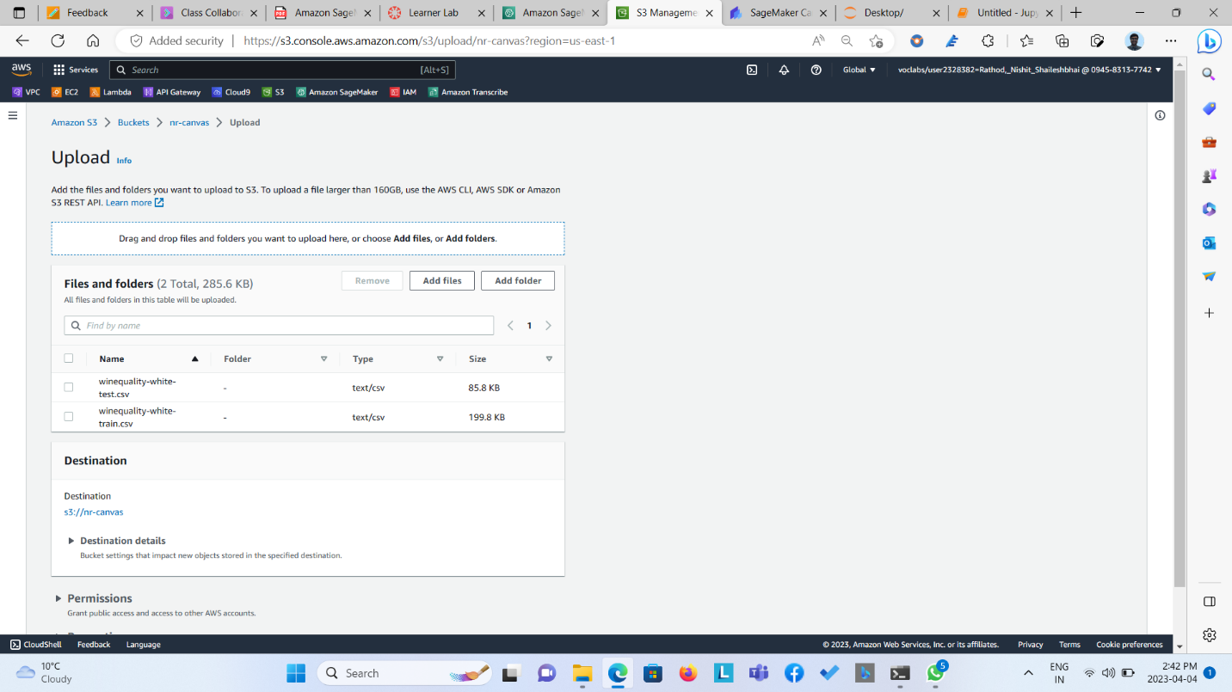  
  
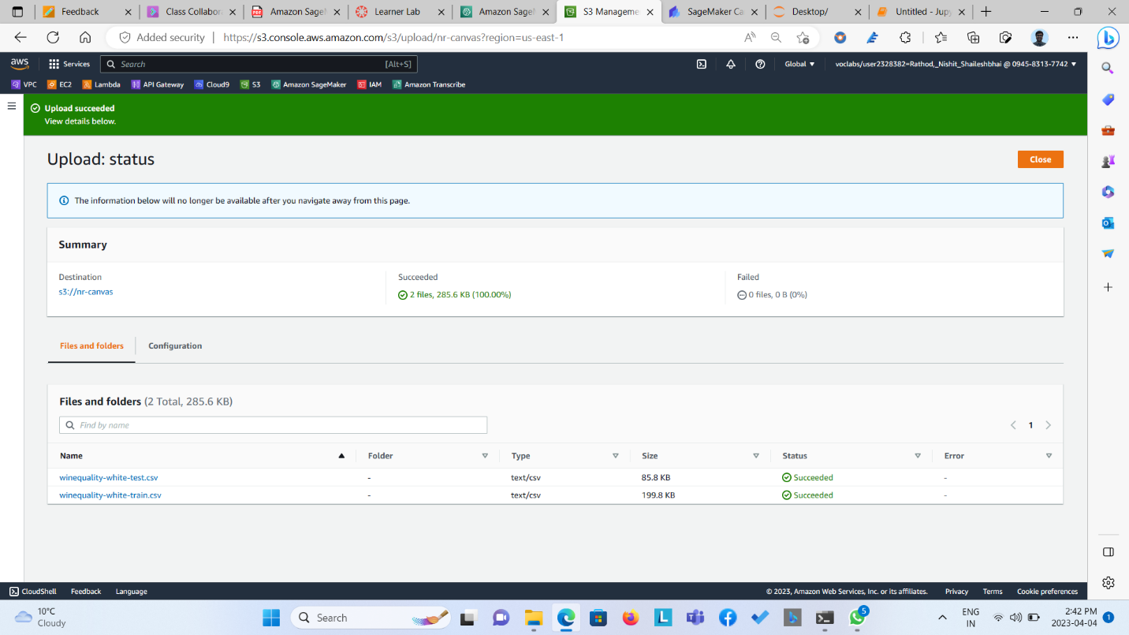  
  
**Step 3: Opened Canvas, Imported the dataset from S3 Bucket and Selected the Train Dataset for training.**  
  
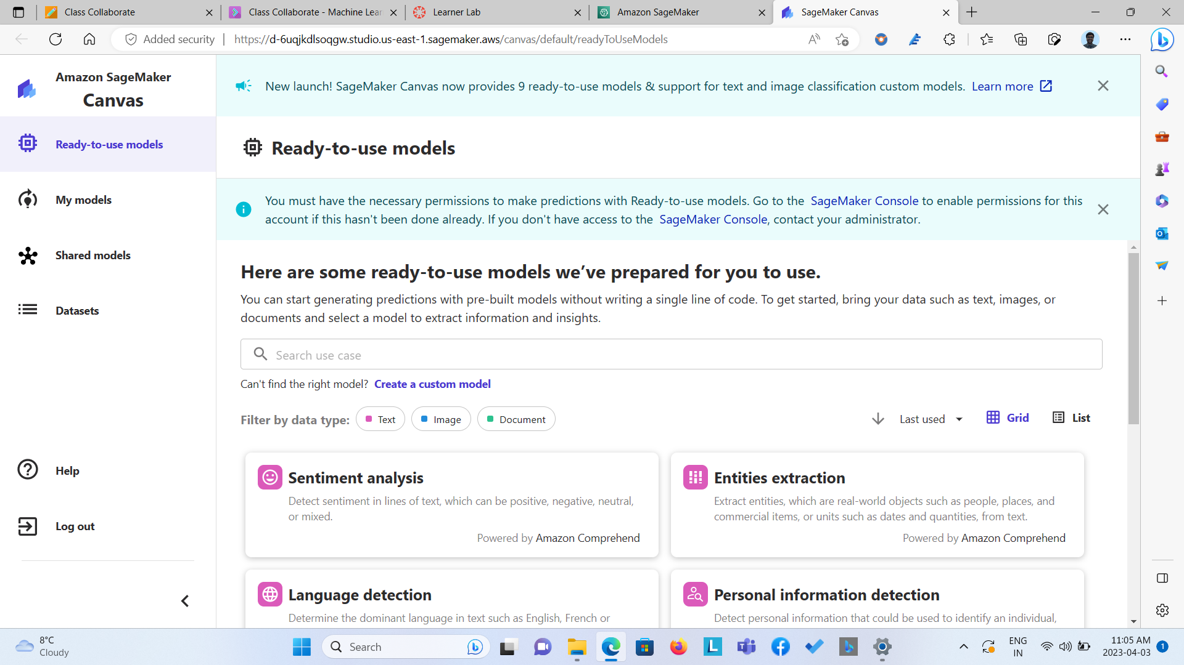

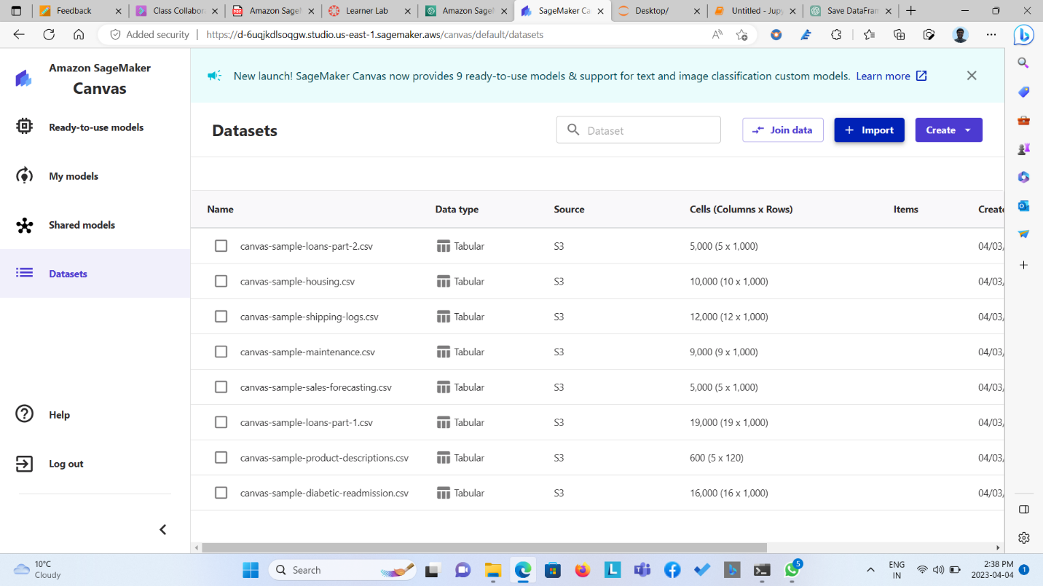

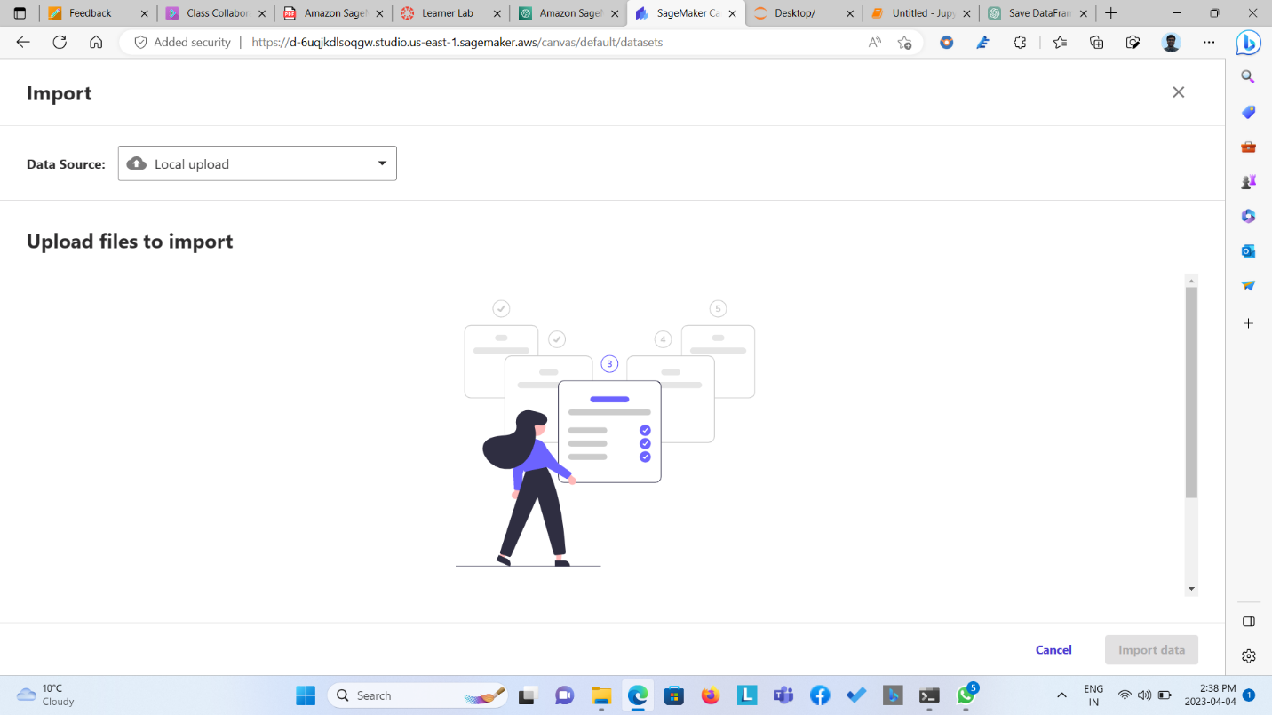

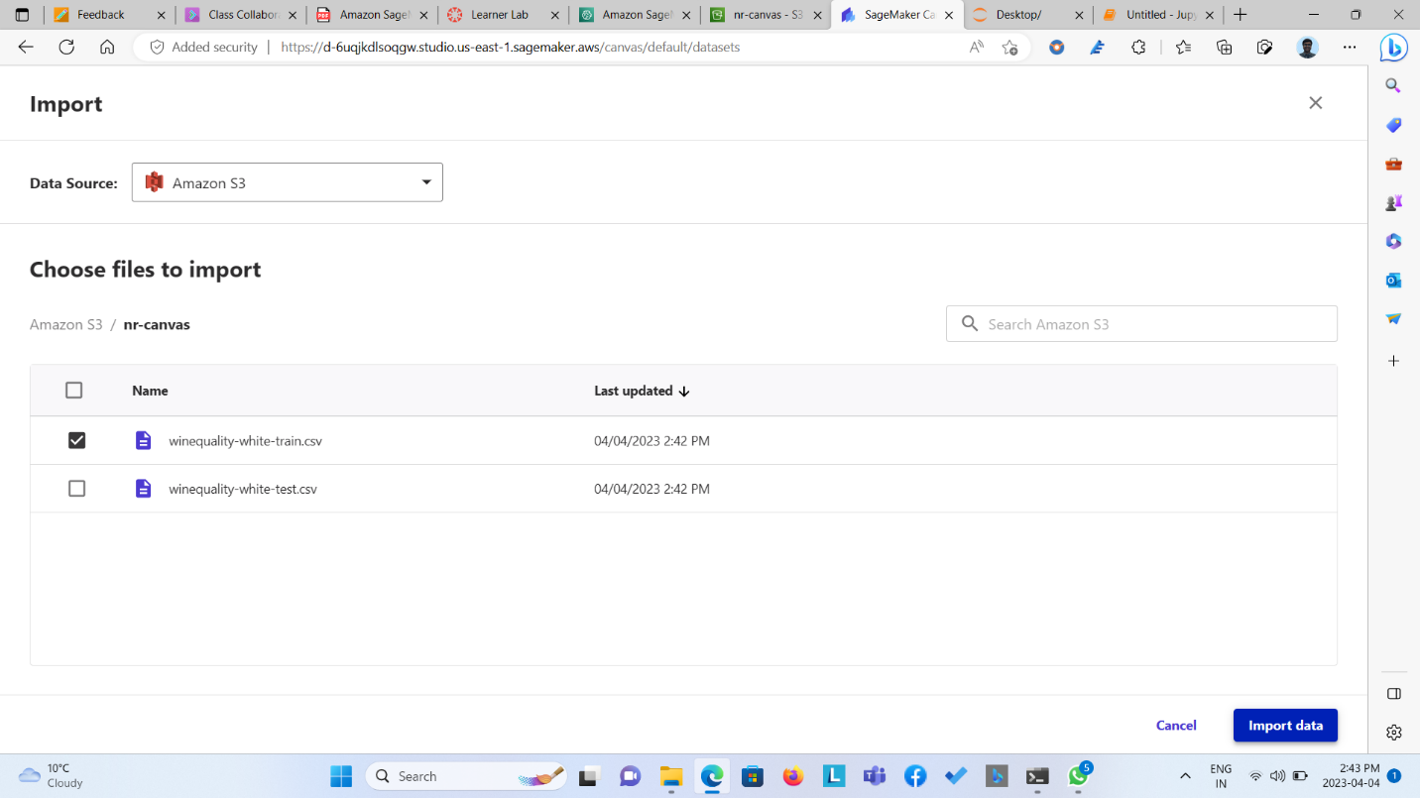

Step 4: Imported the data, Created the Quick model by mentioning Quality variable as Target Variable.

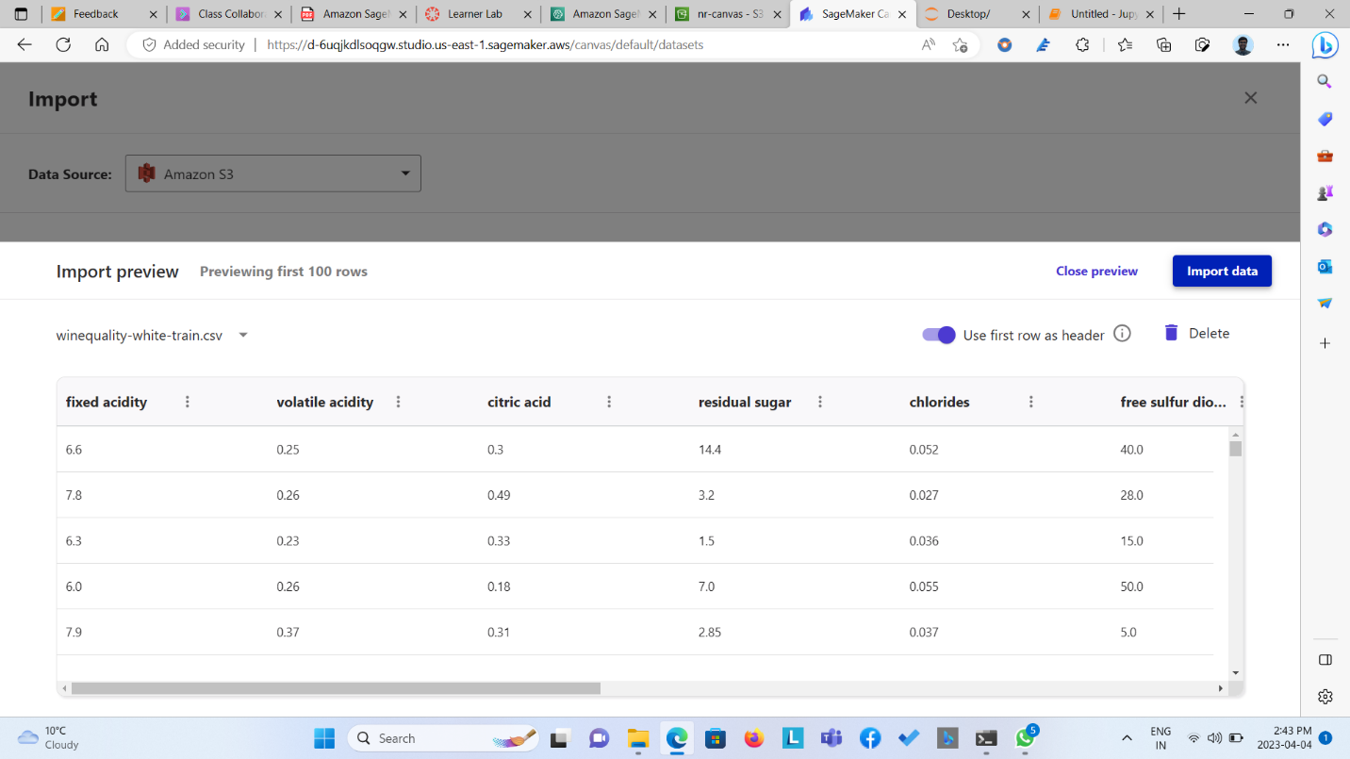

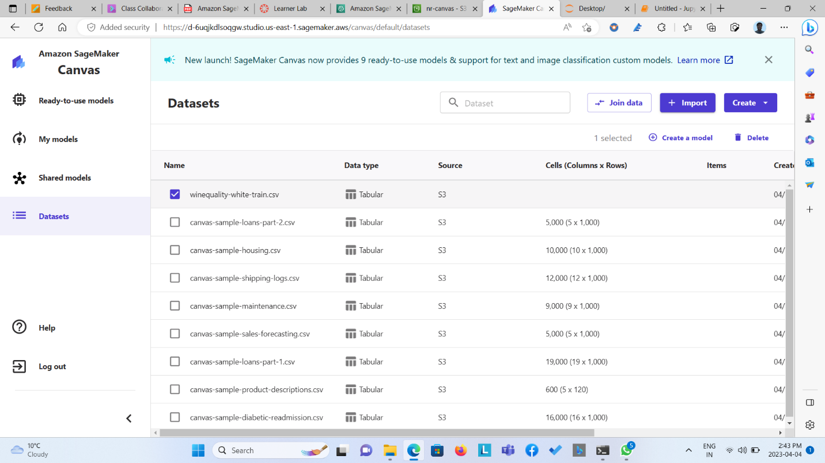  
  
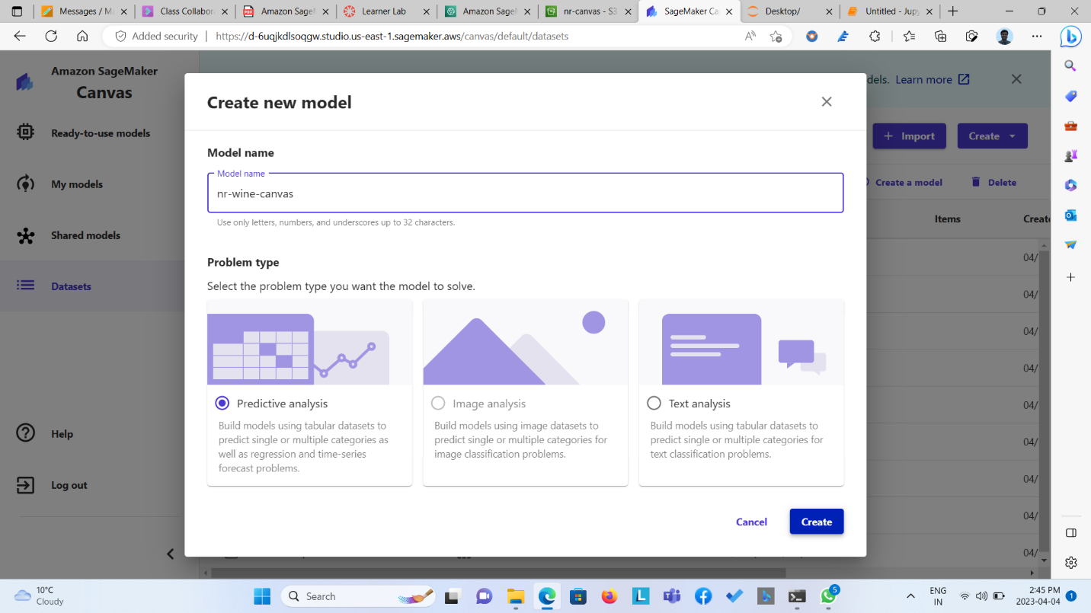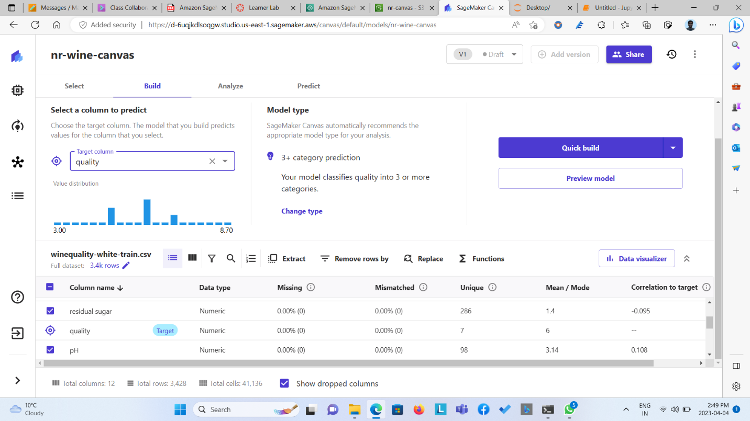  
  
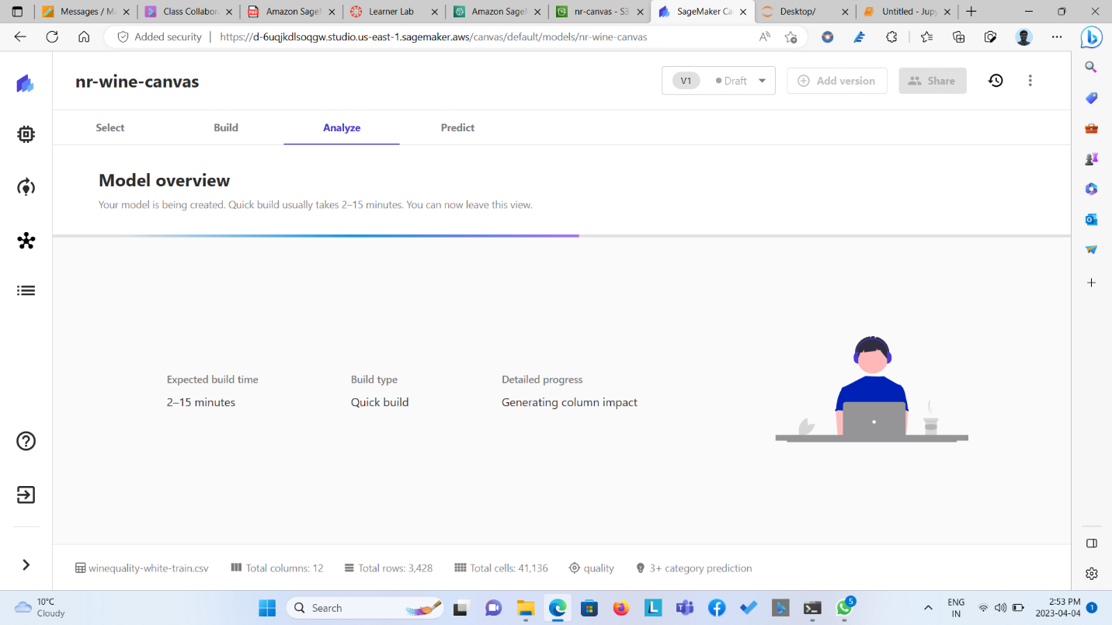

Step 5: The model gave 68.169% of accuracy in predicting the quality. After which prediction was done on the test dataset.

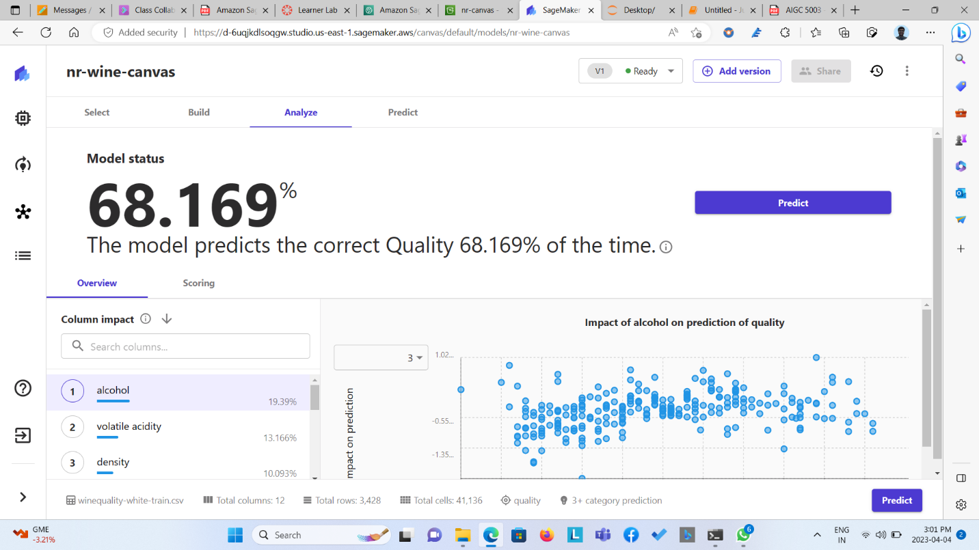  
  
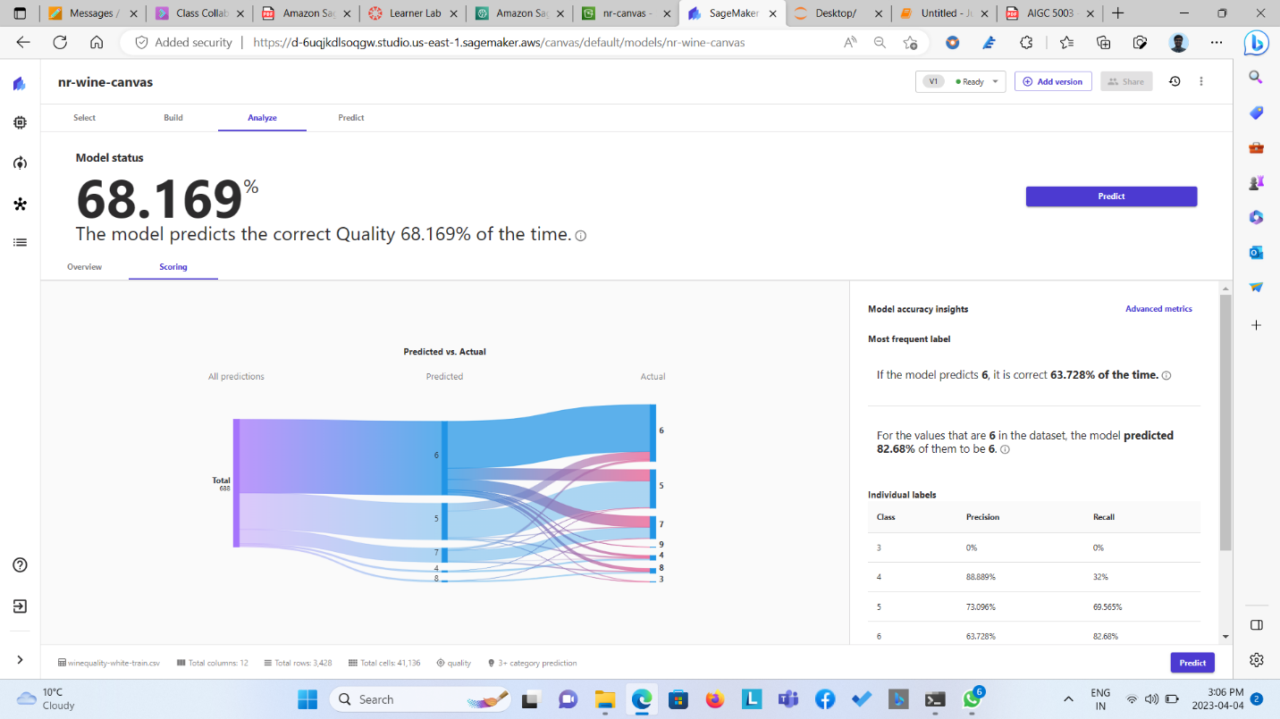  
  
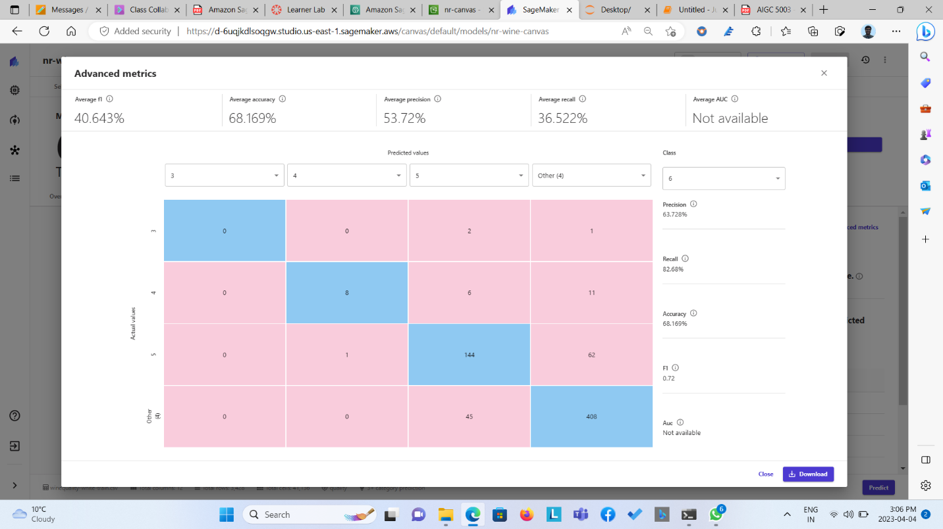

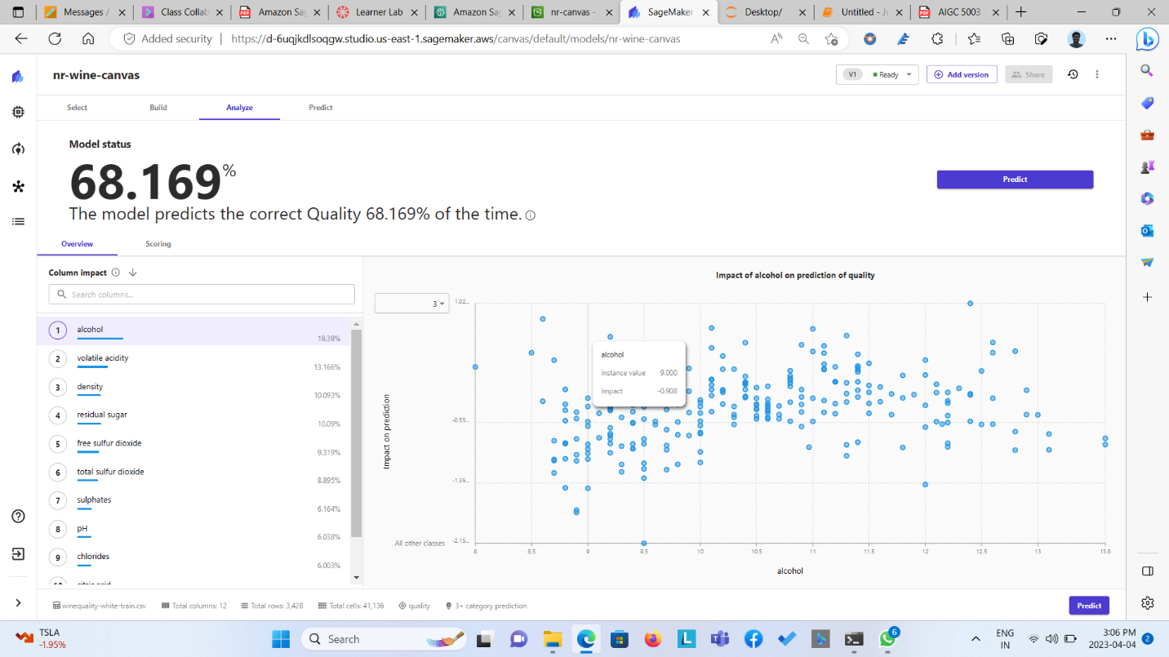

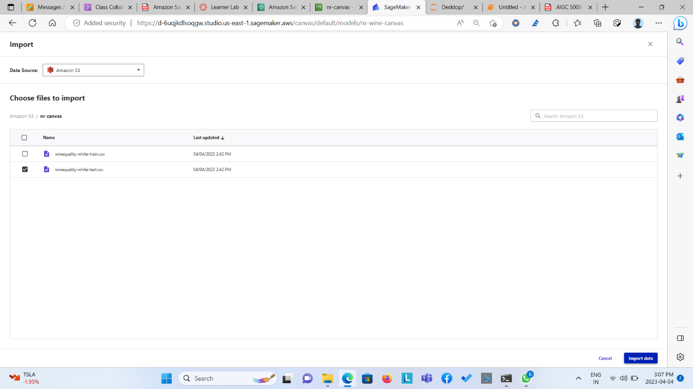  
  
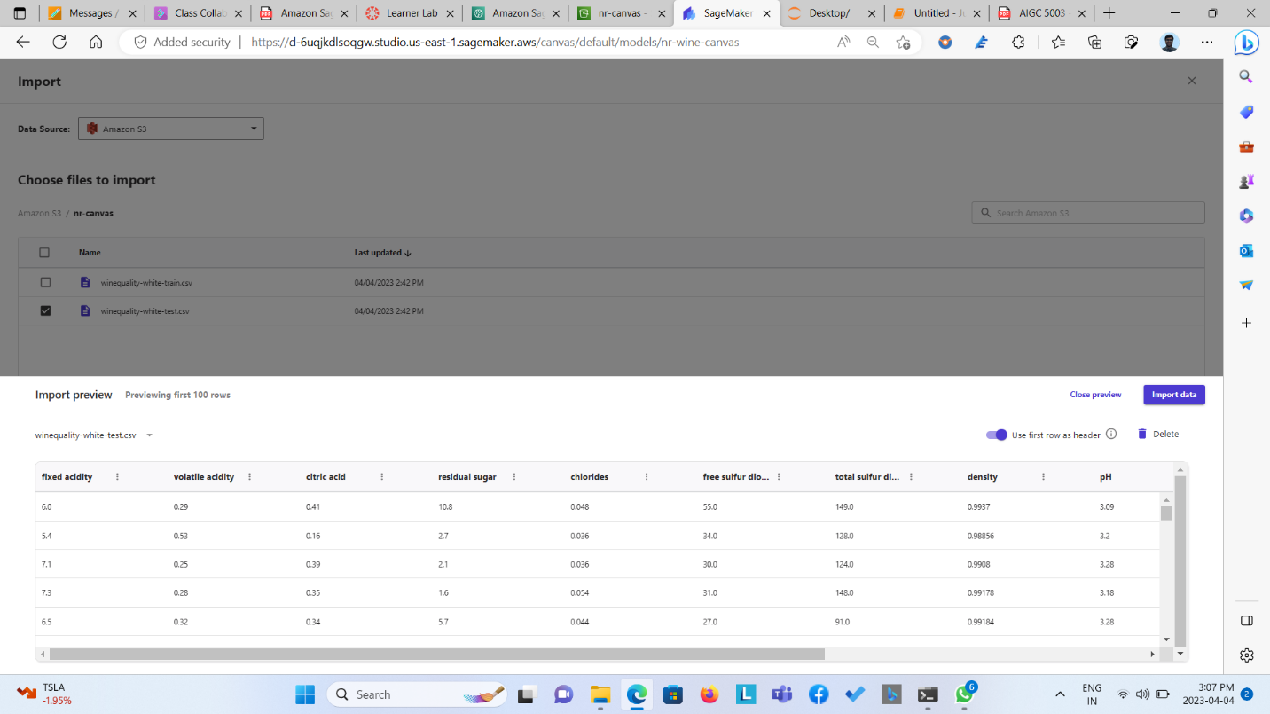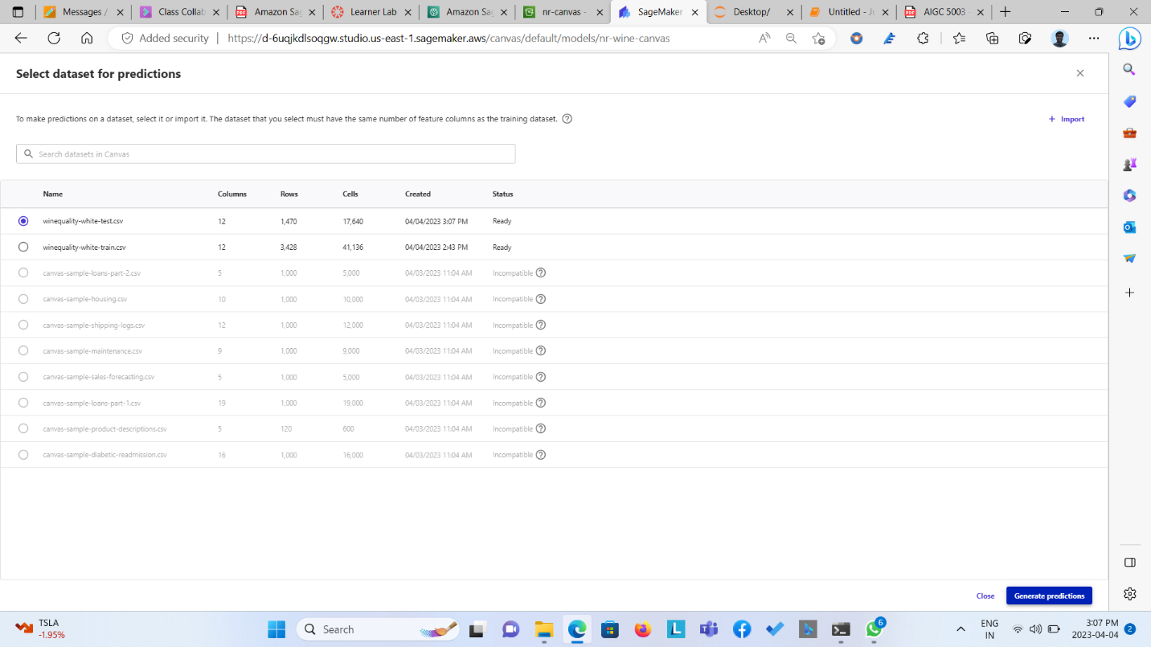  
  
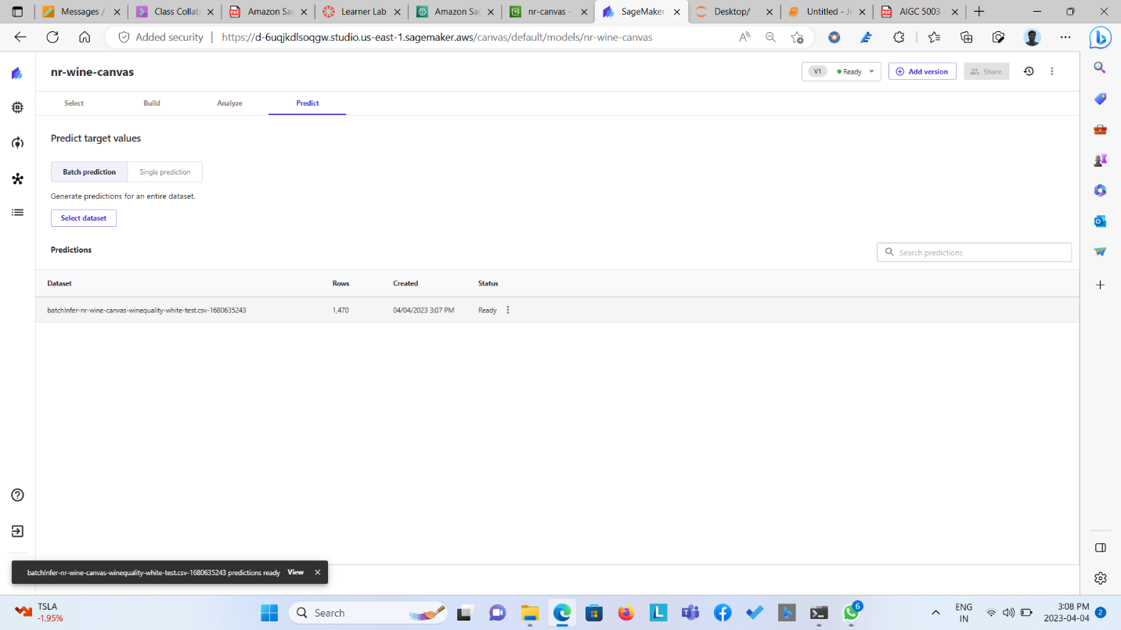  
  
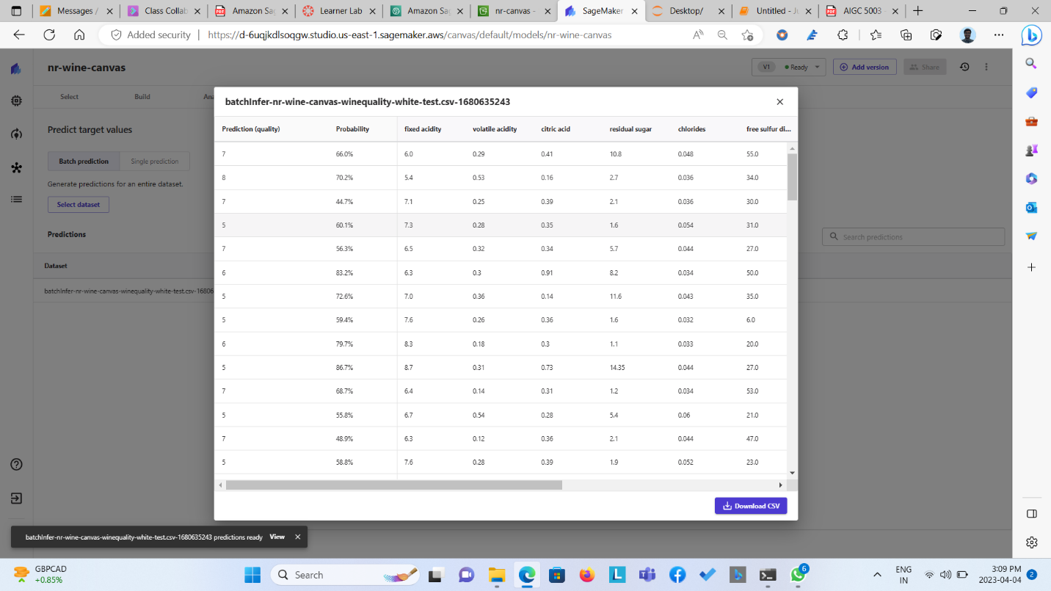

Step 6: New version was created on which same above mentioned process is been carried but this time with Standard model. Here three least significant column is been dropped which resulted into 67.151% of accuracy.

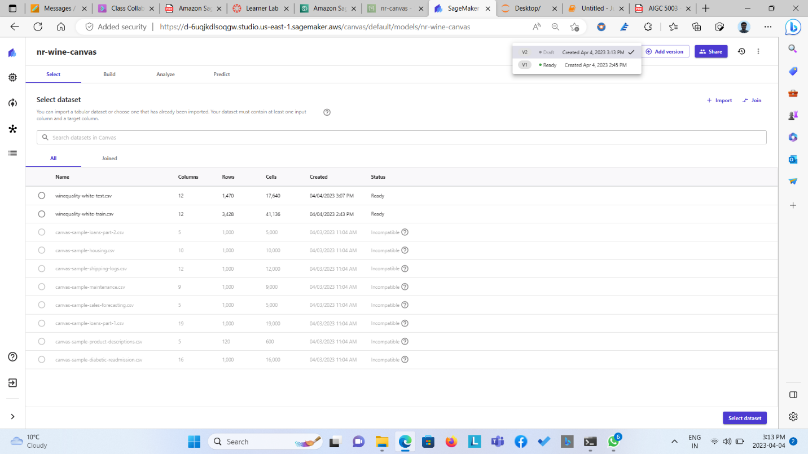  
  
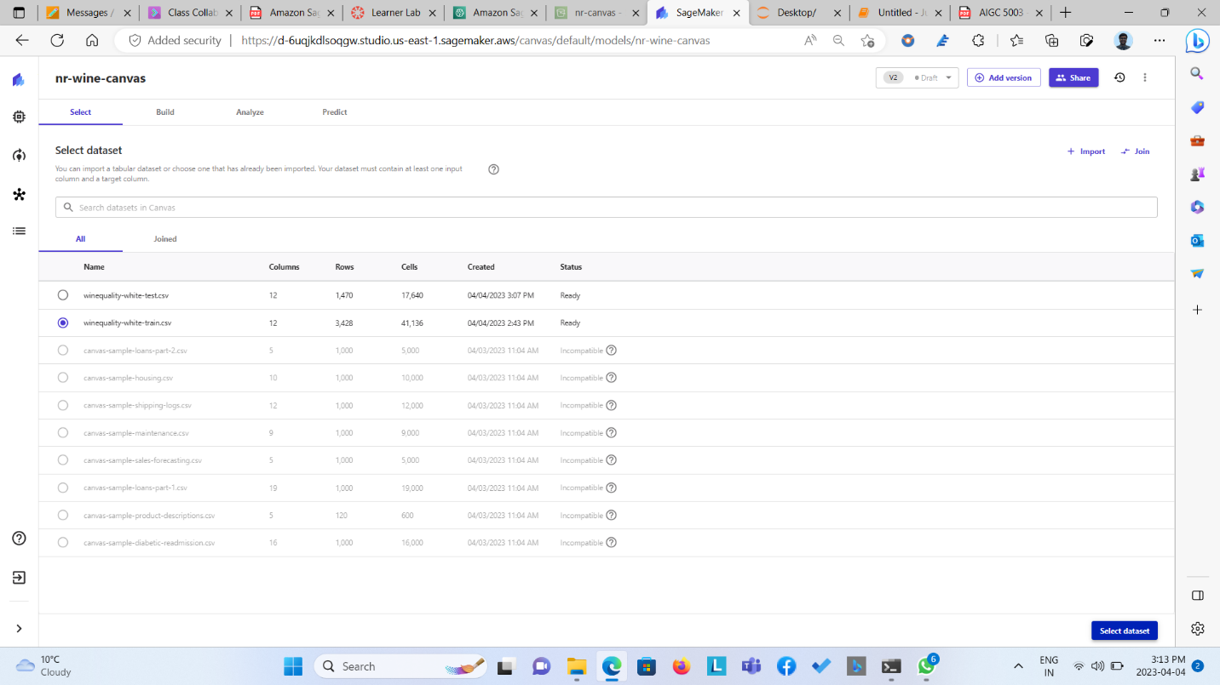  
  
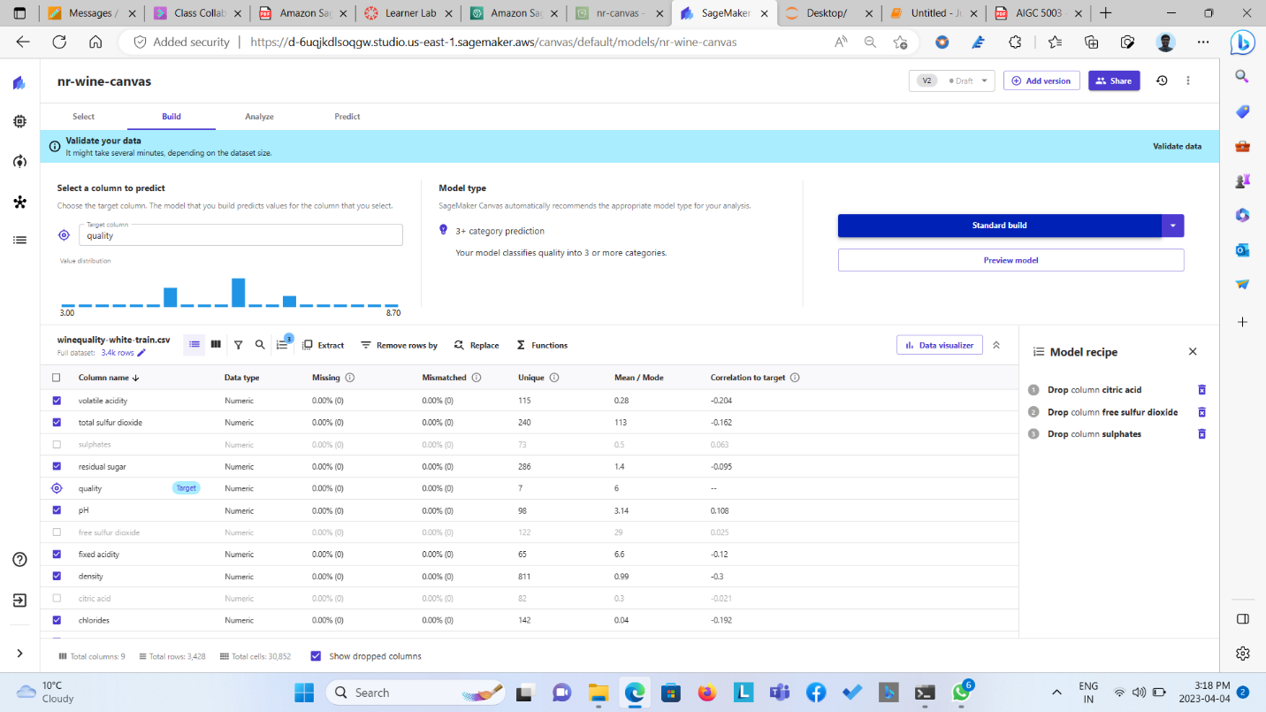

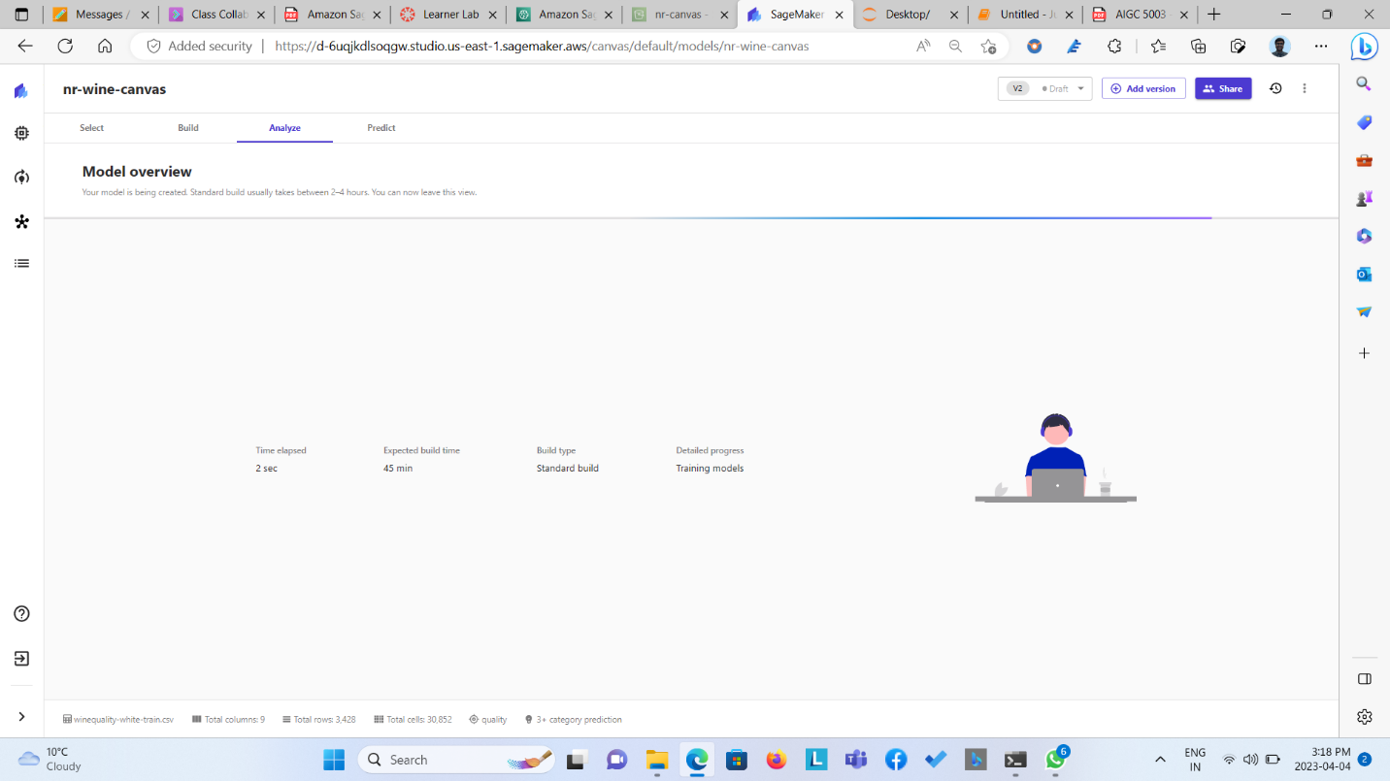  
  
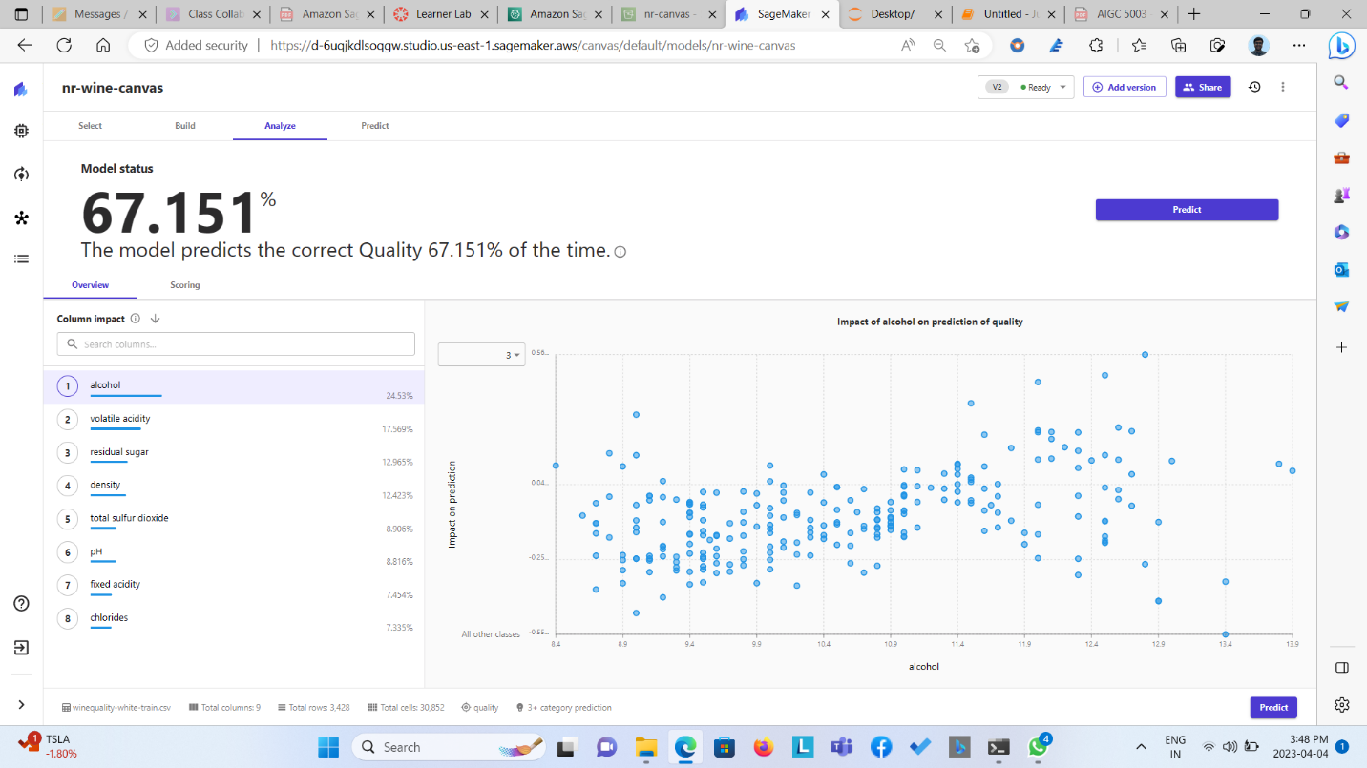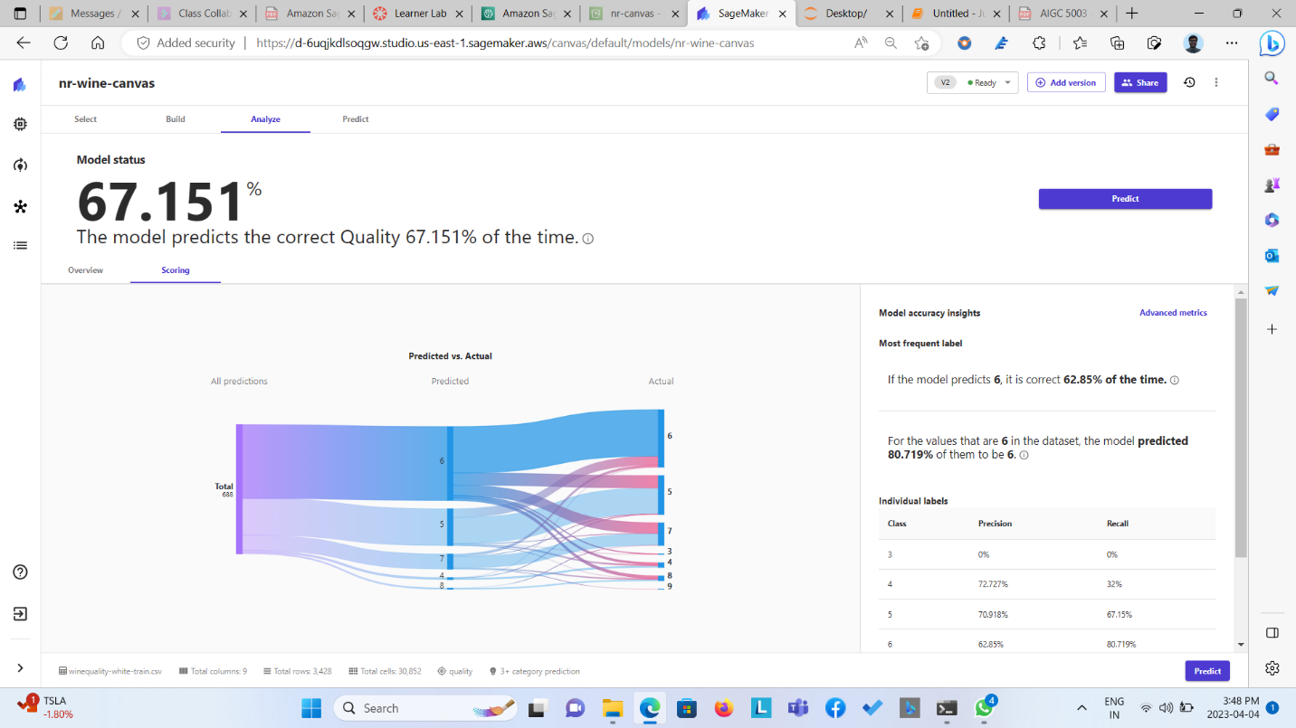  
  
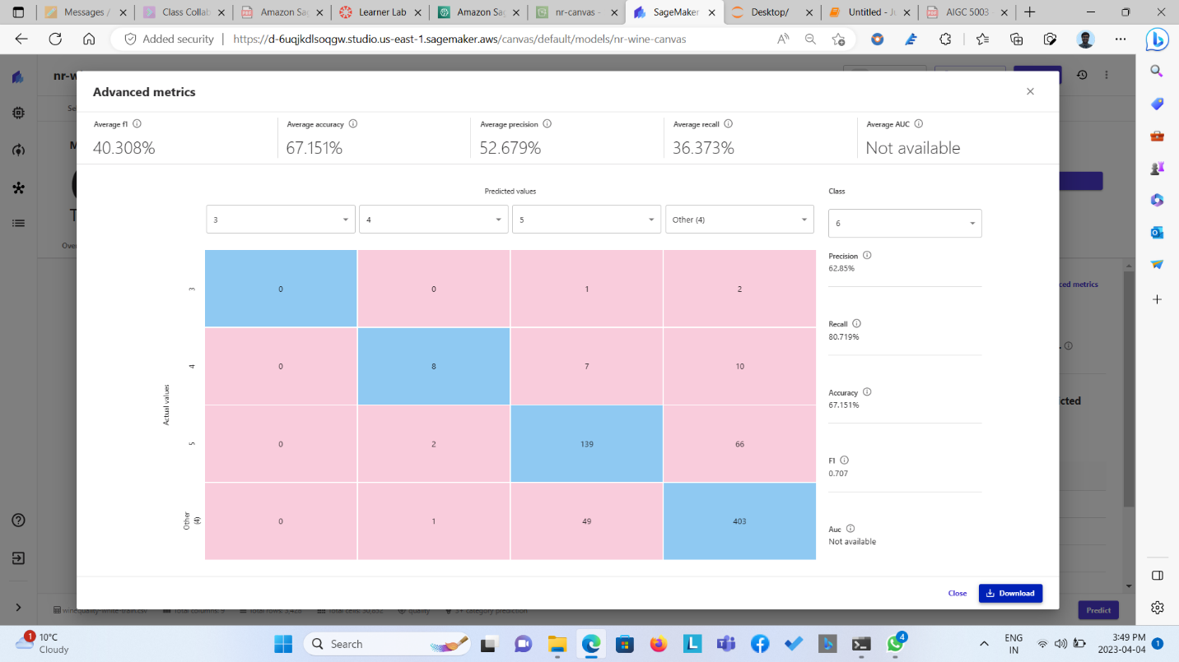

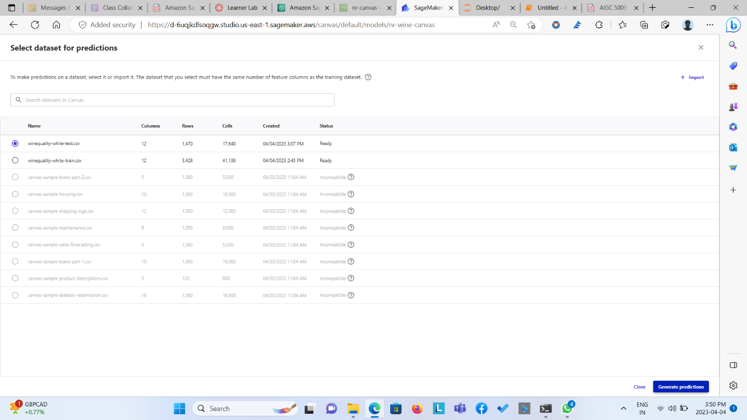  
  
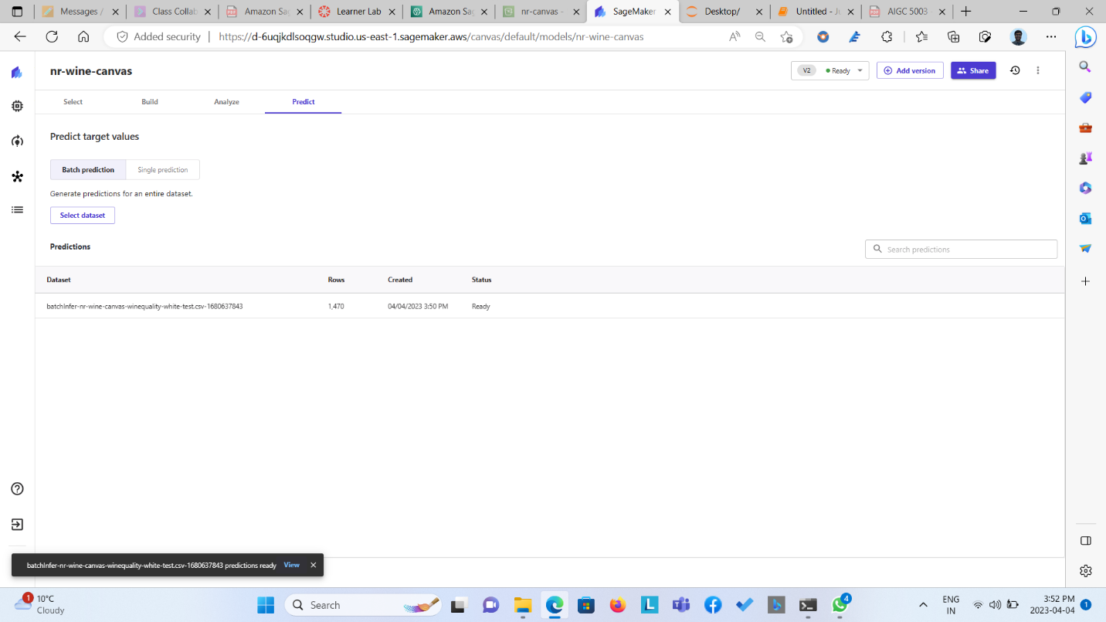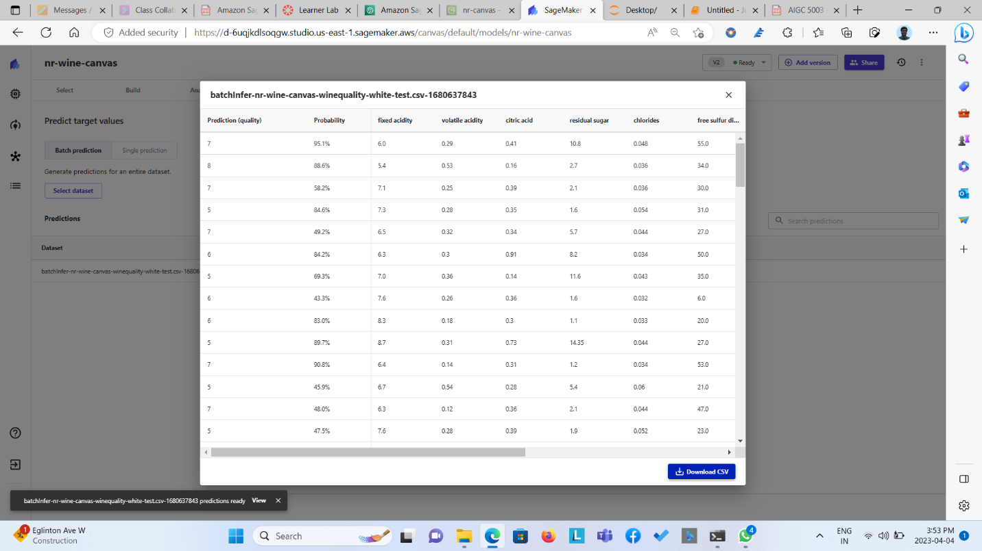  
  
Step 7: The standard model is been shared with the other user so that the shared user can deploy the shared model from sagemaker studio so that he/she can carry out other process with this pretrained model.   
  
